Preparing the Dataset

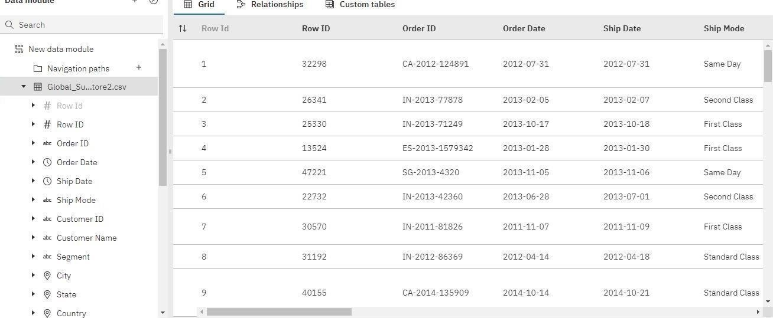

|  |  |
| --- | --- |
| Team ID | PNT2022TMlD06631 |
| Project | Global Sales Data Analytics |
| Roll No | 61071911138 |

